STEP1- Download the latest EPOS software package from the link provided by Network

STEP2- Place the downloaded folder (let’s say EPOSXX – XX is version number) inside hard disk.

STEP3- Open command prompt and go to the **EPOSXX/service** location as mention below –

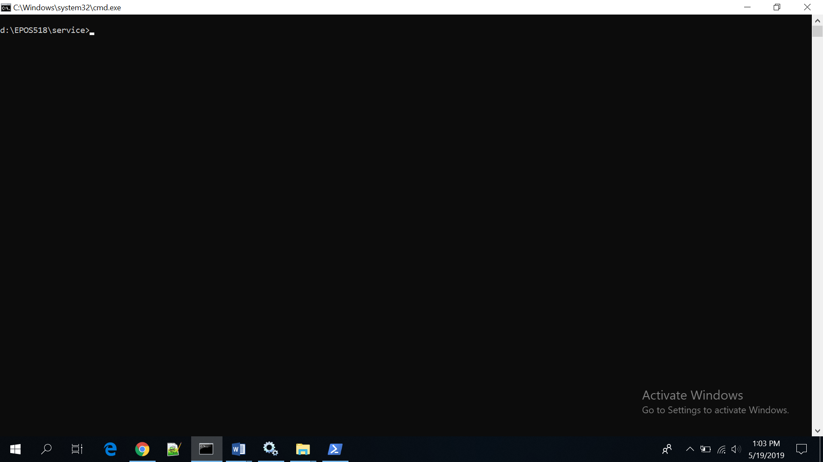

STEP4- Install the NGPASS software by running **ngpas_service_install.bat** as mention below

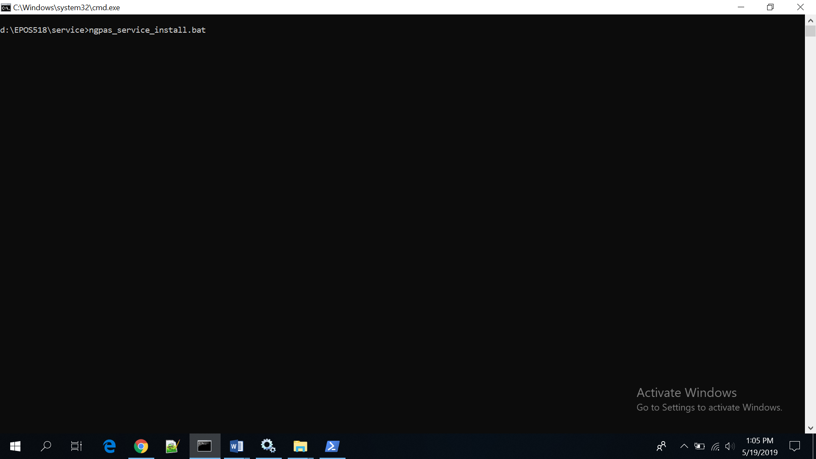

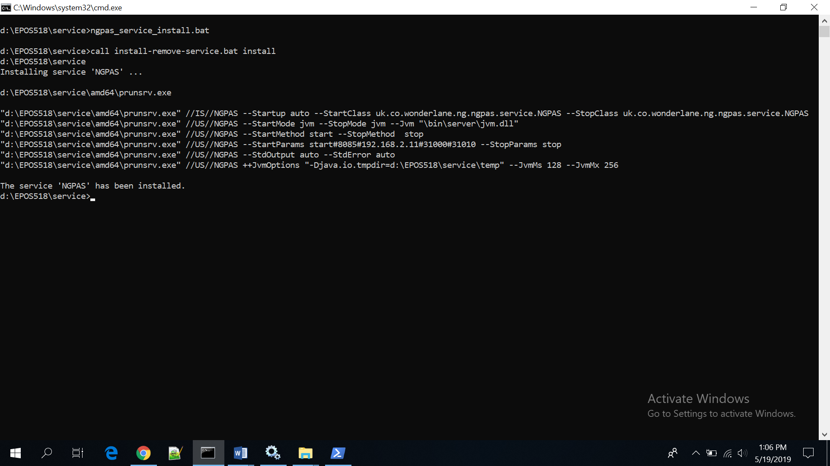

**Note:**

1. **During install it will ask to allow app to make changes 6 times, Press YES button to allow for all the changes.**
2. **Message “The service NGPAS has been installed” should come.**

STEP6- Now type command ngpas_service_config.bat and press YES after that to allow changes

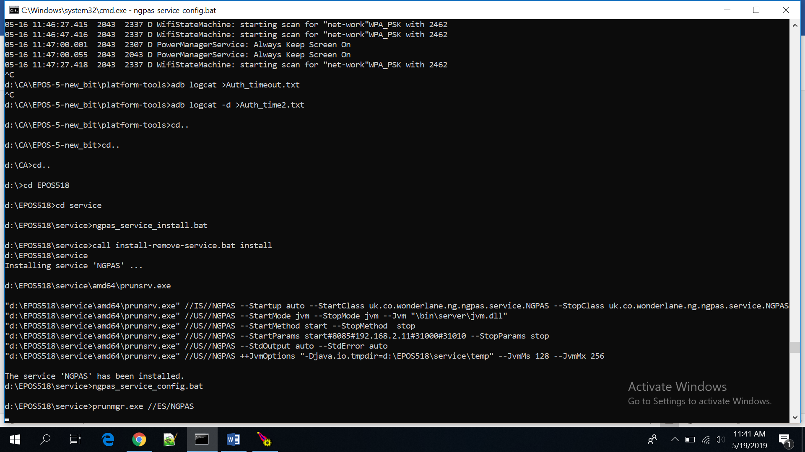

After pressing YES, a new window will prompt as below. Follow below to enter parameter details in each Tab

**General**

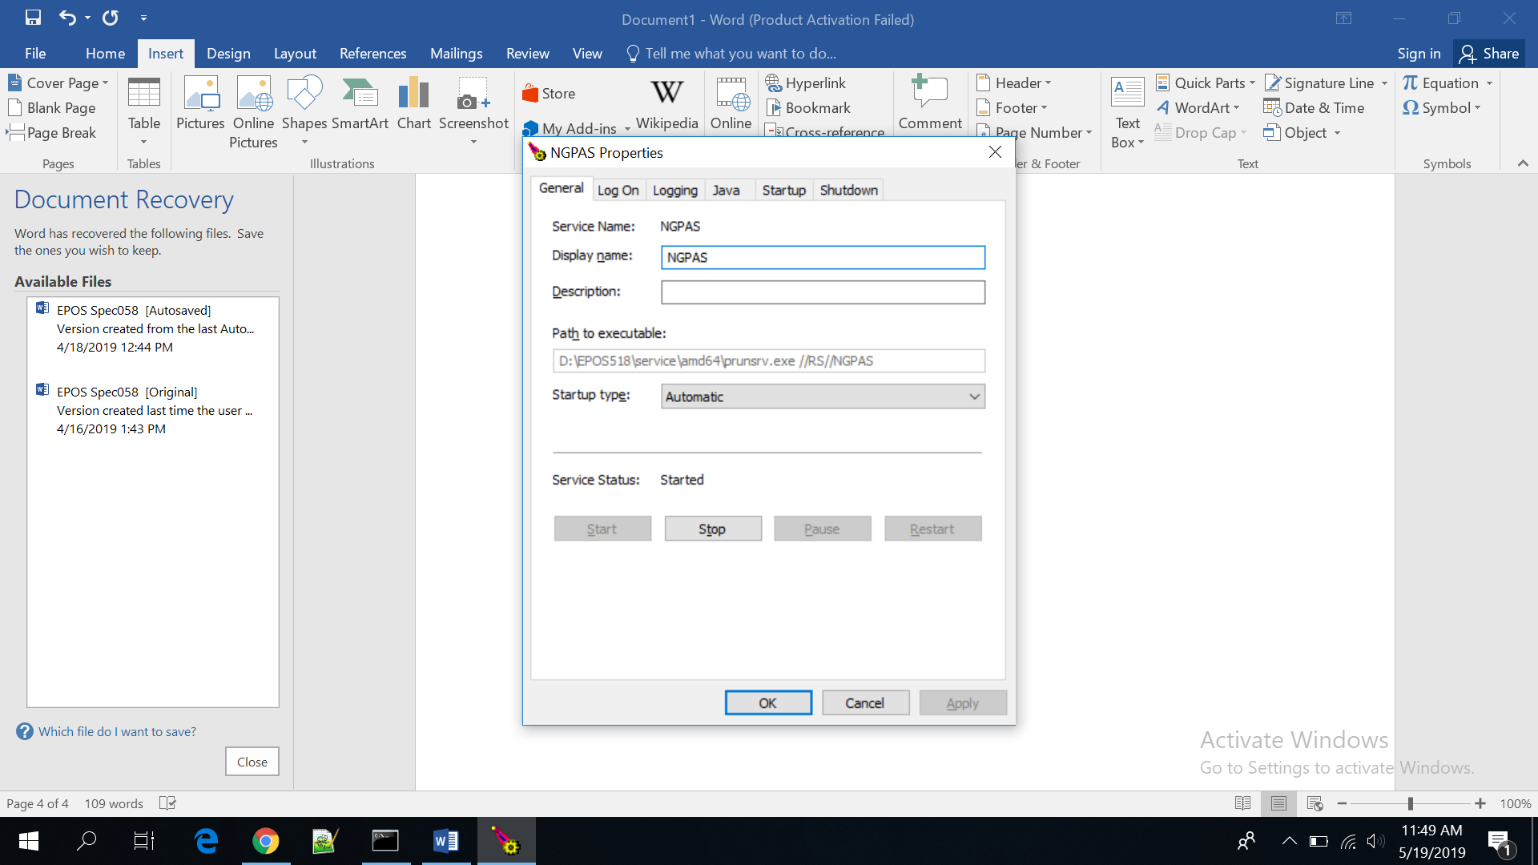

**Log On**

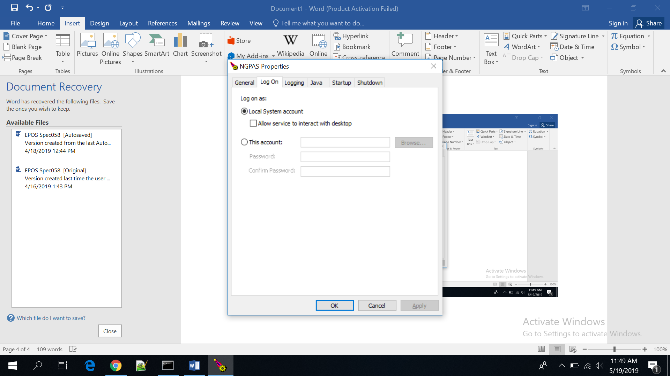

**Logging**

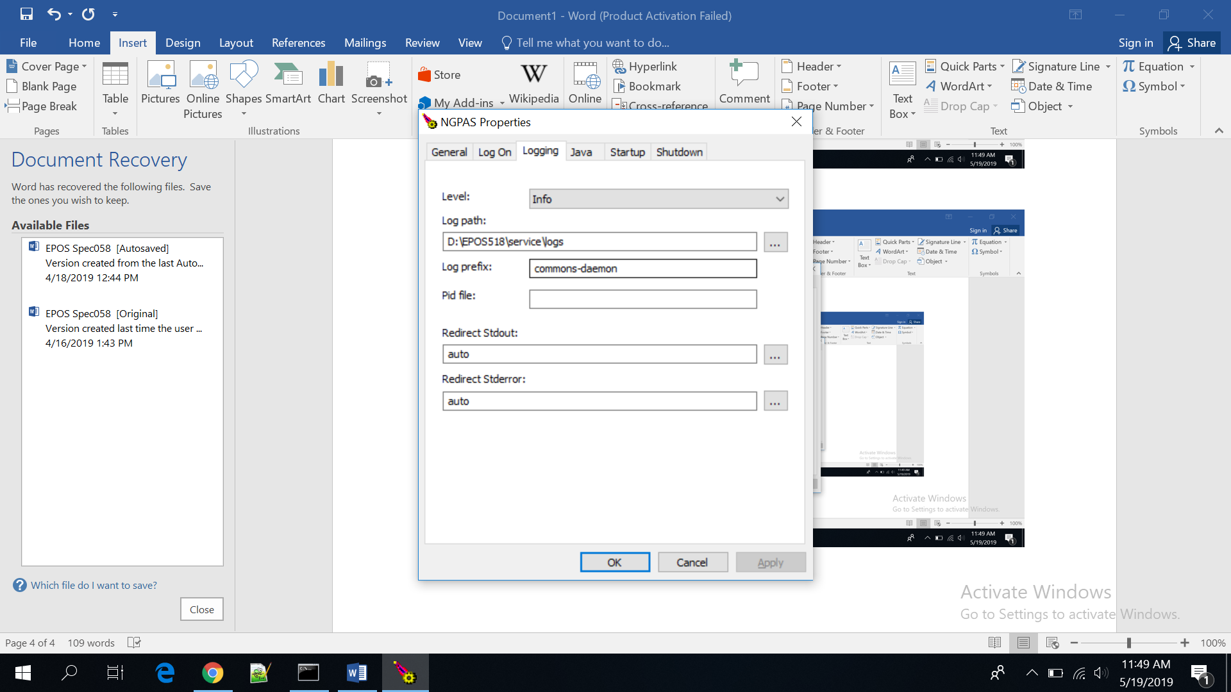

**Java**

On Java Virtual Machine option click on the 3 dots (…) and insert the location of JVM.dll of latest JAVA version installed.

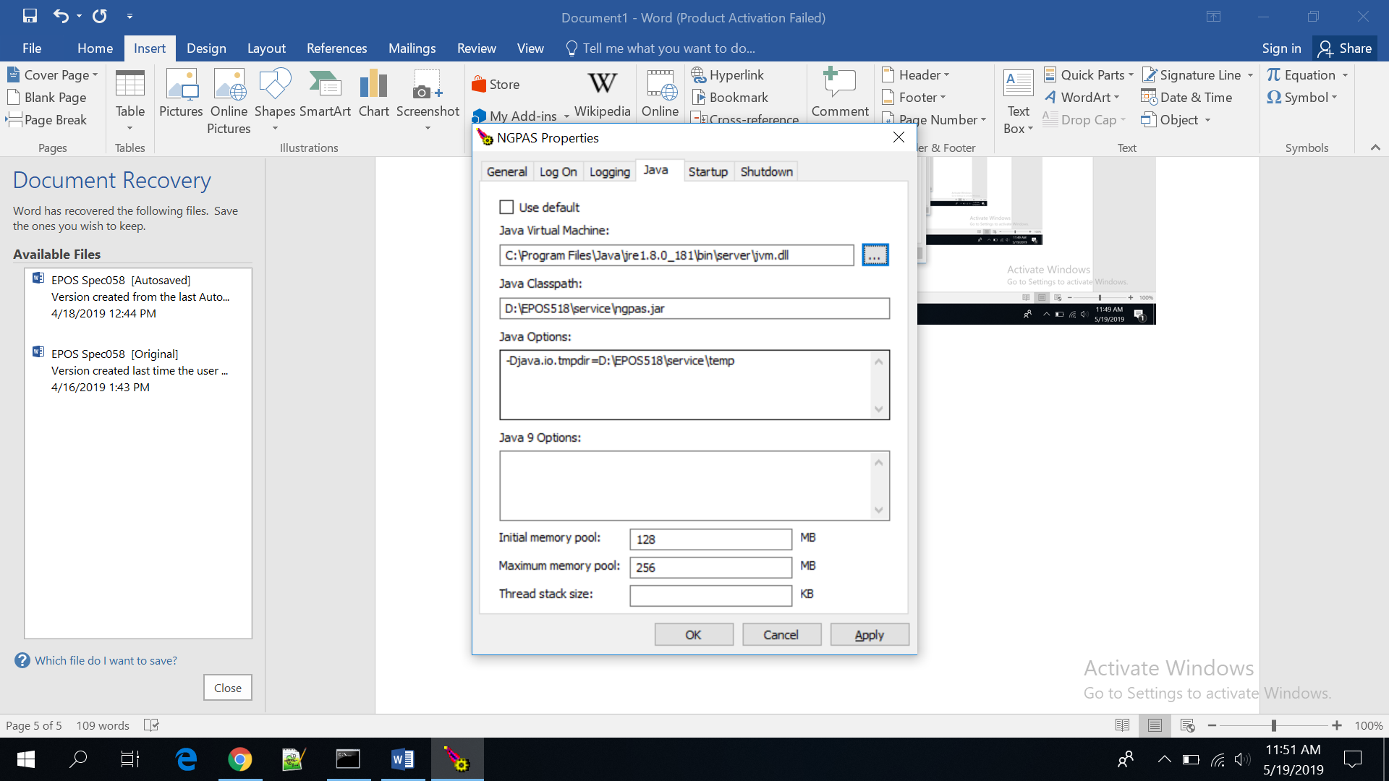

**Startup**

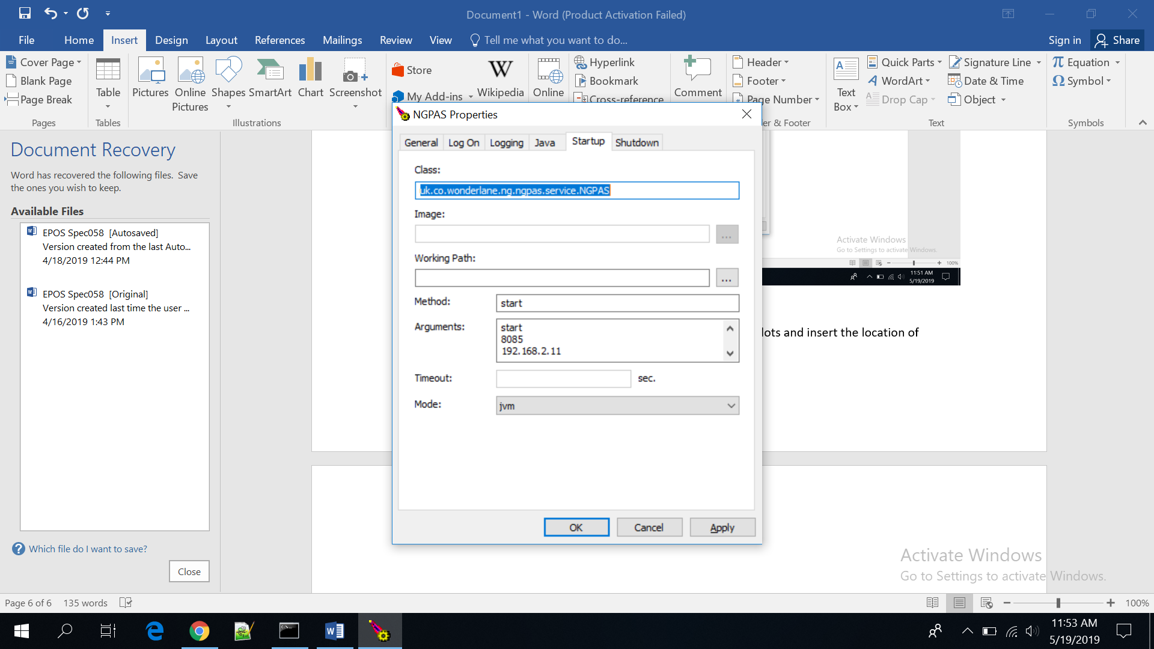

Note:

* In case of EPOS on serial mode: (AP10 device or AT150 device with USB cable):

Remove the IP address and PORT (31000 & 310010) address and put only 8085 as below

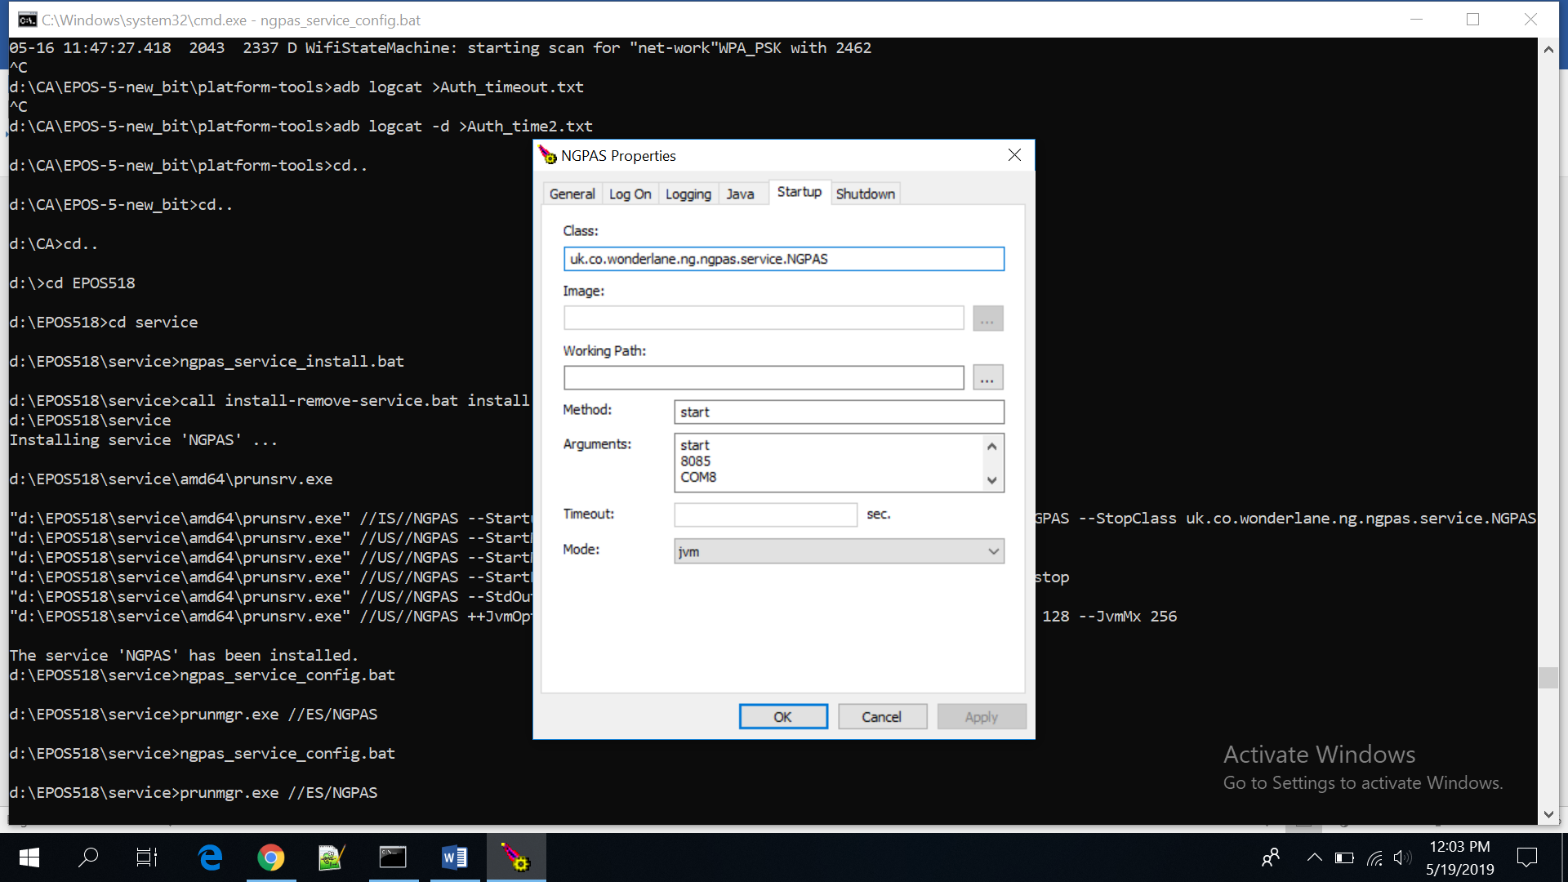

* In case of EPOS on Wi-Fi mode (AT150 device): Just Remove the existing IP address and put IP address of PED device (Go to about option in POS for IP address).

**Shutdown**

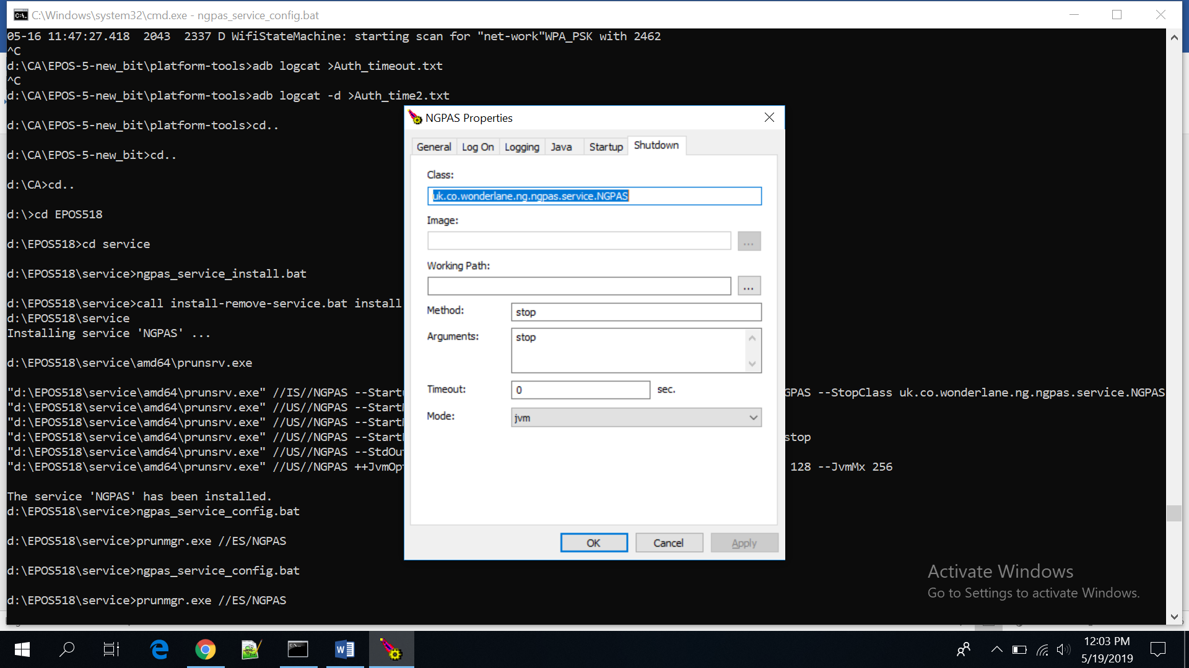

Step 7: Check and start the NGPASS service as below

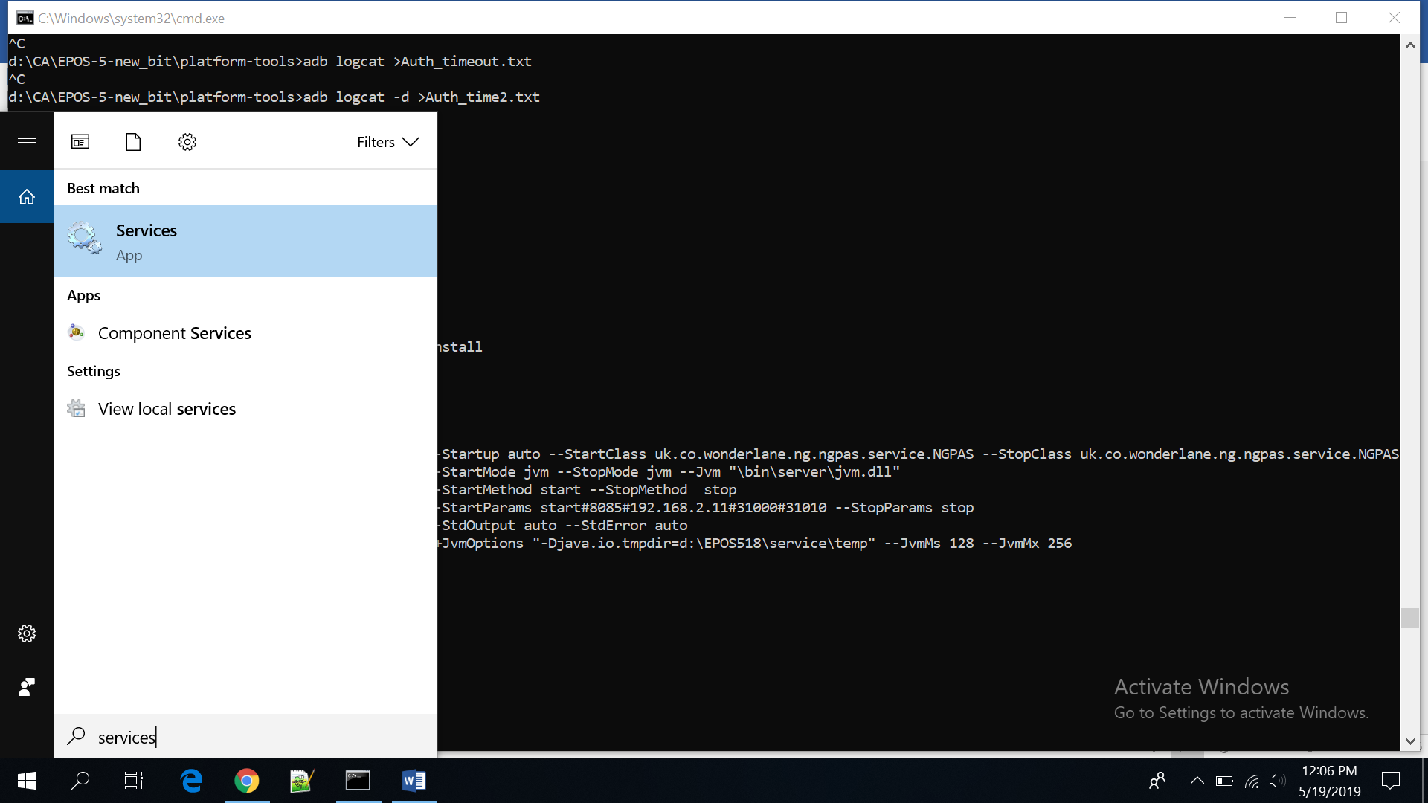

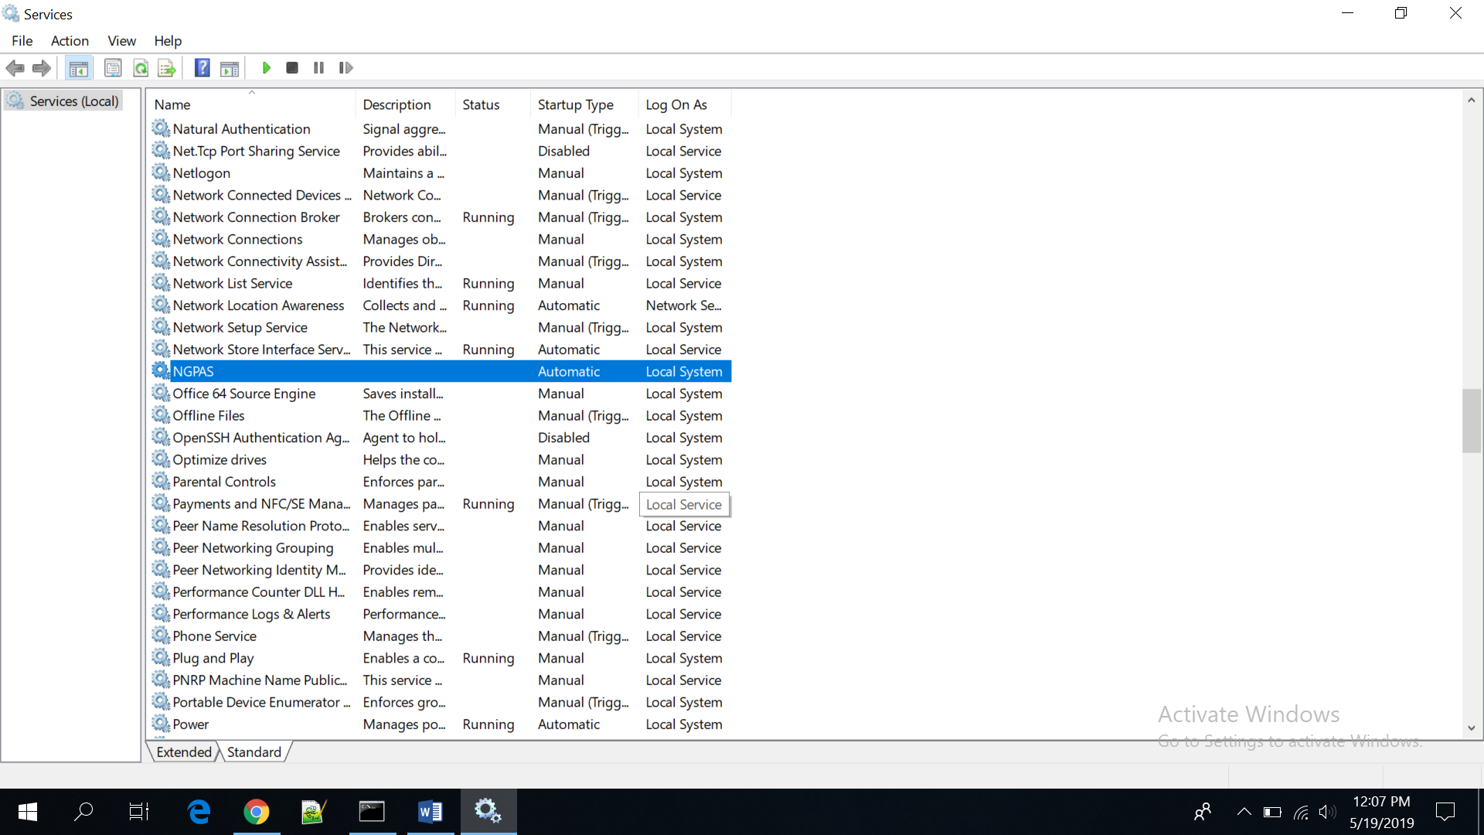

Right click on NGPAS and start the service

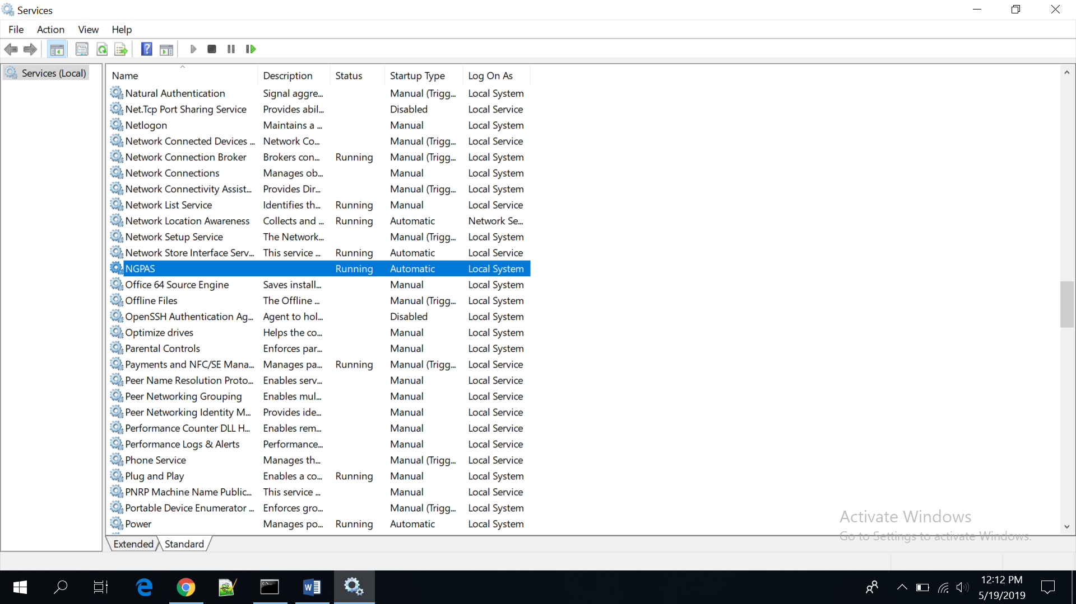

In case of windows 7 or less insert the IP address in hosts file present in **“C:\Windows\System32\drivers\etc.”** as below

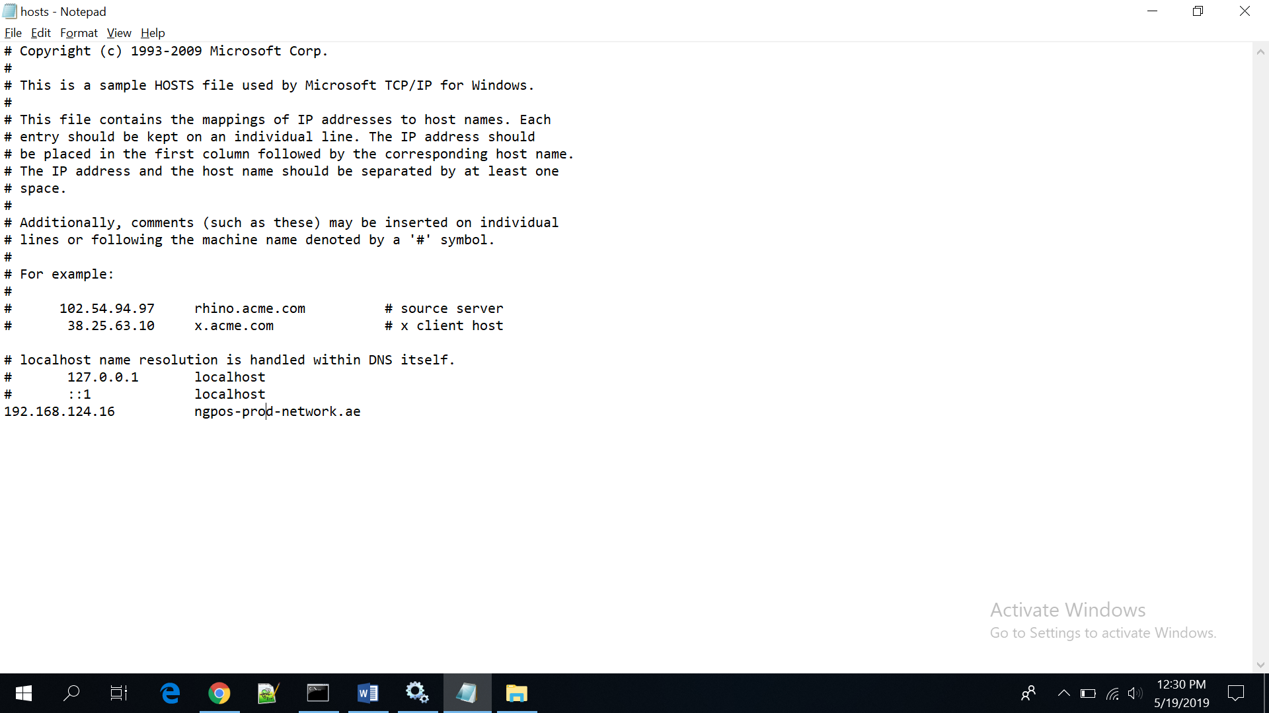

**Steps 8:** Check logs if device is communicating to POS device

Open Power shell and go to **EPOSXX\service\logs** location

Type command **gc .\ngpas-stdout.2019-05-19.log –wait**

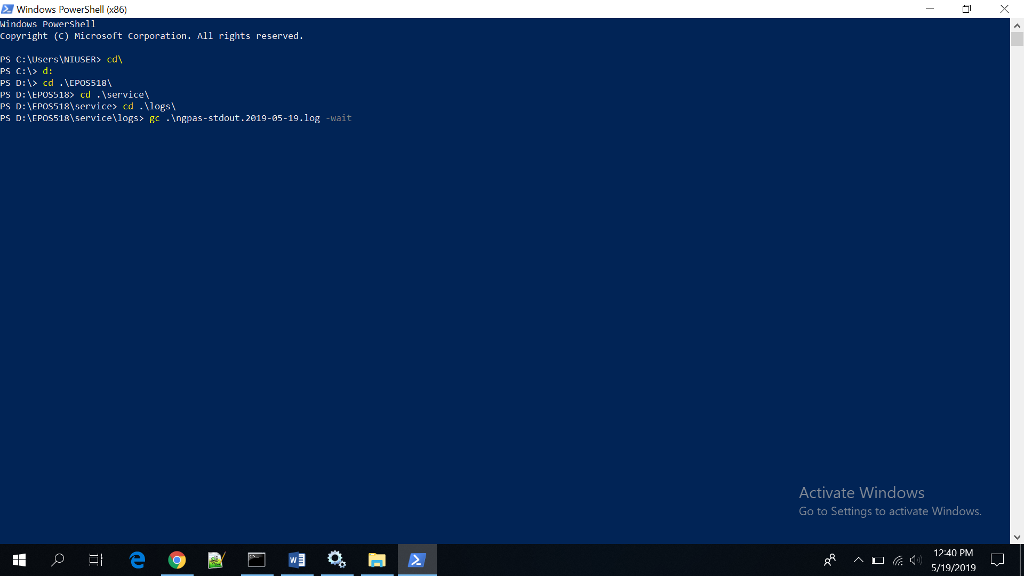

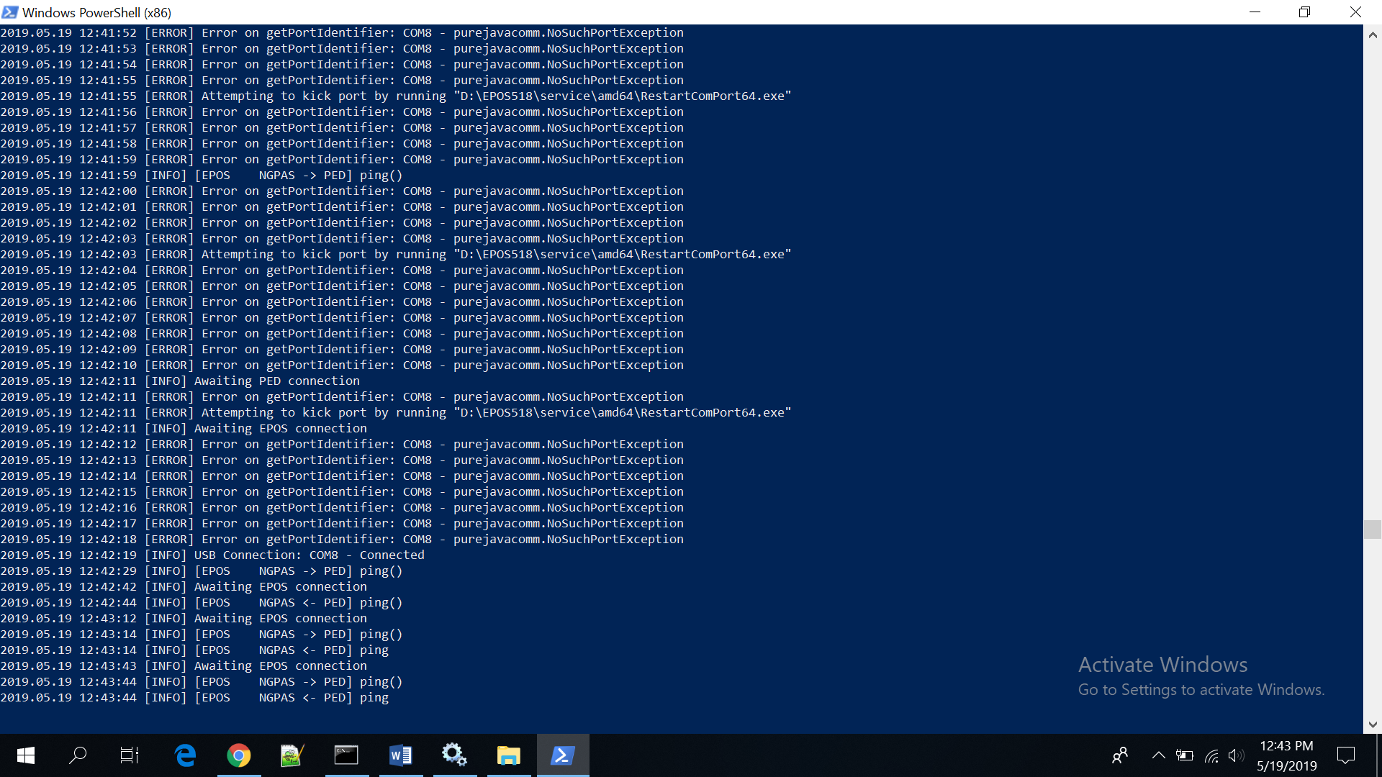

Logs should show “USB Connection: COM8 – Connected”